**continuous positive airway pressure (CPAP) units**

**These units are also called:** continuous positive pressure breathing (CPPB).

Uses :

CPAP units are commonly used to provide breathing assistance to patients with obstructive sleep apnea (OSA) or sleep apnea .

CPAP also may be used to treat pre-term infants whose lungs have not yet fully developed

use CPAP in infants with respiratory distress syndrome. It is associated with a decrease in the incidence of bronchopulmonary dysplasia. In some preterm infants whose lungs have not fully developed, CPAP improves survival and decreases the need for steroid treatment for their lungs.

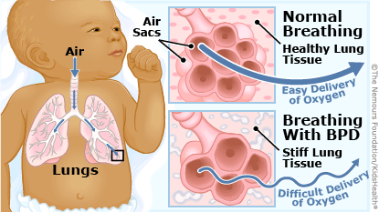

OSA refers to the periodic cessation (apnea) or reduction (hypopnea) of breathing due to narrowing of the upper airways during sleep. It is characterized by excessive snoring and periodic breathing with repetitive apneas, hypopneas, and arousals leading to fragmented sleep

The primary symptom is daytime sleepiness, and it is thought to be a cause of premature death, hypertension, ischemic heart disease, stroke, depression, and traffic accidents (as a result of sleepiness while driving

CPAP units used as preventive and support device for patients with other diseases, such as acute asthma, congestive heart failure, cardiogenic pulmonary edema, cystic fibrosis, and chronic lung disease (CLD )

**Component :**

CPAP devices consist of :

a flow generator or “blower,” a length of tubing, and a tight-fitting face mask, nasal mask, or nasal nares.

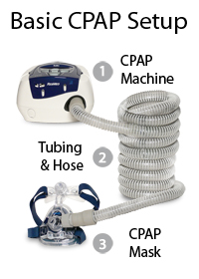

**Mechanism :**

CPAP therapy uses machines specifically designed to deliver a constant flow of pressure. Some CPAP machines have other features as well, such as heated humidifiers. CPAP is the most effective treatment for [obstructive sleep apnea](https://en.wikipedia.org/wiki/Obstructive_sleep_apnea), in which the mild pressure from the CPAP prevents the airway from collapsing or becoming blocked. It is an alternative to positive end-expiratory pressure (PEEP). Both modalities stent the lungs' alveoli open and thus recruit more of the lung's surface area for ventilation, but, while PEEP refers to devices that impose positive pressure only at the end of the exhalation, CPAP devices apply continuous positive airway pressure throughout the breathing cycle. Thus, the ventilator itself does not cycle during CPAP, no additional pressure above the level of CPAP is provided and patients must initiate all of their breaths .

**Complications:**

Swallowing of air into the stomach may occur